Outdoor Sectoring

Introduction

This tutorial provides advice on how to successfully sector an outdoor area. Experience with the first expansion pack showed that it was possible to have areas of the sky appear black if the sky portals and sectors were not properly done. The tutorial level OutdoorSectoring01 provides an example of how to build an area without having black holes appear in the sky.

Causes of sky anomalies in FEAR

Figures 1 and 2 show examples of having black regions appear in the sky in the FEAR expansion pack Warehouse_01 and Hospital_03 levels. There are areas of these levels in which the sky appears normal, but if you take a step to the side a black area will suddenly appear where the sky is not rendered. Unfortunately these problems were not discovered until the day the game was to be finished, so there was not enough time to fix and test them before the game shipped.

Figure 1: Black sky region (labeled A) in Warehouse_01.

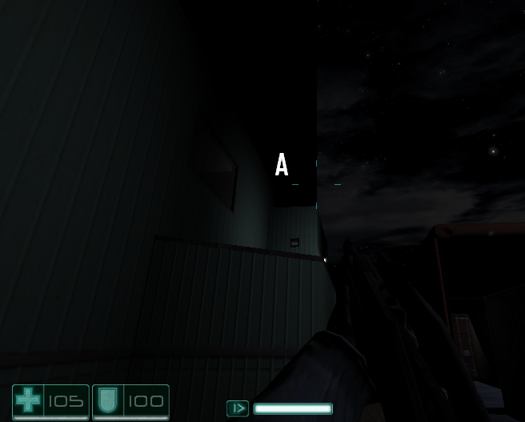

Figure 2: Black sky region (labeled A) where the sky does not render in Hospital_03.

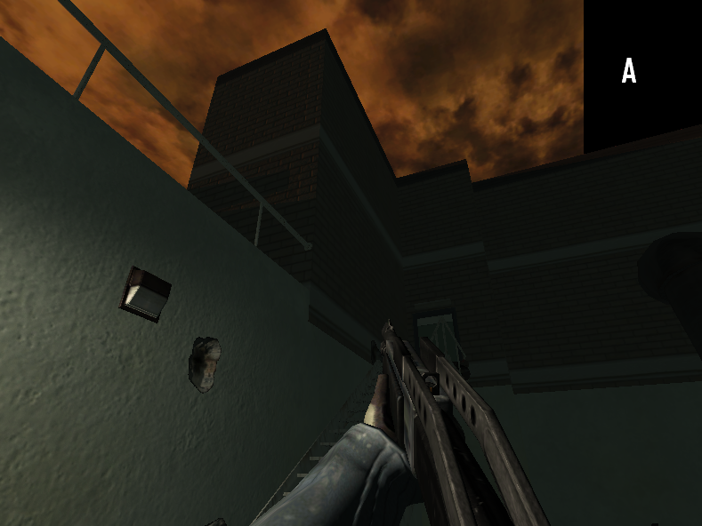

Warehouse_01 Sky Anomaly

Figure 1 illustrates the turret fight area of Warehouse_01. Figure 3 shows a diagram of how the sky area was constructed. If you stand at location X and look at the sky then the area covered by brush A is black and not rendered. Here the problem seems to occur where two separate sky portal brushes meet. Four separate sky portal brushes were used and were level with the top of the buildings. Both of the sky portals were in the same sector, so rendering different sectors was not a problem. It seems that where sky portal brushes meet there can be a problem where one of the brushes will not render when standing at a certain location.

Figure 3: Schematic diagram of the four sky portal brushes that made up the sky in the turret area fight of Warehouse_01.

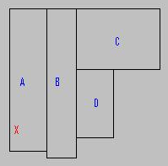

I also found that if you used one brush for the sky sector (here replacing A, B, C, and D with one large rectangular brush), then where it intercepts a building there were also rendering problems. Having a sky portal brush intercept another breaks the sky portal into two brushes and rendering problems can occur at the intersection.

To fix the problem the sky was extended up from the buildings and a single brush was used for the top sky portal. A single sector also encompassed the entire top of the sky. Figure 4 shows diagrams of the sectoring and construction of the new sky area.

Figure 4:

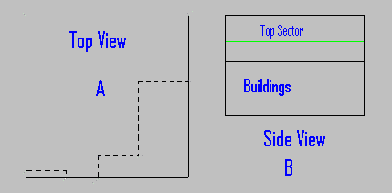

Figure 4: Panel A shows a top view of the area. Dotted lines illustrate the building outline. A single sky portal brush extends across the entire region. Panel B gives a side view of the area. Sky portal brushes extended above the building height. A single sector was placed above the other sectors and covered the entire sky portal brush on top.

Hospital_03 sky anomaly

Figure 2 shows the sky in Hospital_03. Figure 5 provides a schematic diagram of the level. Basically, a giant box enclosed the city and playing area. Each side was only one sky portal brush. However, the different sectors of the playing area extended up to the sky. This effectively broke the sky portal brush into separate brushes, causing the sky to appear black where two sectors intercepted. This problem was easily fixed by moving all the sectors that touched the top sky portal down a few meters and placing a single sector on top that covered the entire sky surface. Figure 5 shows the level after the fix, with one sector covering the entire sky portal at the top. Before the fix the sectors from the playing area extended up to the top sky portal.

Figure 5: Schematic side view of Hospital_03.

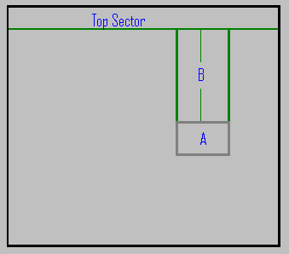

Figure 5: A schematic side view of the Hospital_03 level. A shows the play area, while B represents sectors extending above this area. The Top Sector covered the entire sky portal brush at the top of the box.

Tutorial Level OutdoorSectoring01

The tutorial level OutdoorSectoring01 gives an example of how an area with buildings can be sectored to prevent black patches from appearing in the sky. Figure 6 is a schematic diagram of the area showing the sectors and buildings.

The courtyard is enclosed in three sectors labeled A, B, and C in Figure 6. The courtyard has 3 buildings. Two of these have doors leading to small rooms, while a larger room with windowed double doors is in the center. Each of the smaller rooms is in its own sector. The doors without windows will block visibility, so it makes sense to have the smaller rooms have their own sectors. Since doors with glass windows do not block visibility, there is no reason to place the larger central room in a separate sector.

Figure 6:

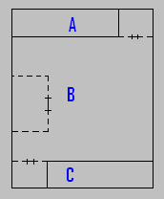

Figure 6: Courtyard sectors for the level OutdoorSectoring01. The location of buildings is represented by dashed lines.

A large sector on top of the others covers the entire top of the sky. This ensures that the single sky portal brush on top is not divided into separate brushes by sectors, which could lead to problems as observed in the Hospital_03 level.

Figure 7 shows the sectors as they appear in the level editor. The sectors labeled A and B correspond to A and B as shown in Figure 6. D is a small sector placed above the building, while E is the small room sector. F is the sector that covers the entire top of the sky.

Figure 7: Sectors as seen in the level editor.

